EXPERIMENT- 20
Perform Sharpening of Image using Laplacian Mask with Negative Center Coefficient
Aim
To write a Python code to sharpen an image using Laplacian mask with negative center coefficient in OpenCV for enhancing image details.
Code
import cv2
import numpy as np
from google.colab.patches import cv2_imshow
from google.colab import files
uploaded=files.upload()
image_path=list(uploaded.keys())[0]
image=cv2.imread(image_path)
if image is None:
print("Error: Image not found")
else:
gray_image=cv2.cvtColor(image,cv2.COLOR_BGR2GRAY)
kernel=np.array([[0,1,0],[1,-4,1],[0,1,0]],dtype=np.float32)
sharpened_image=cv2.filter2D(gray_image,-1,kernel)
print("Original Image")
cv2_imshow(image)
print("Sharpened Image")
cv2_imshow(sharpened_image)

Output Image
Sharpened Image
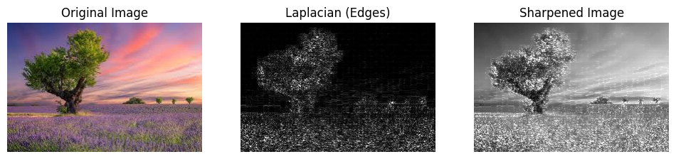
Result
Thus, the image was successfully sharpened using Laplacian mask with negative center coefficient in OpenCV.

